

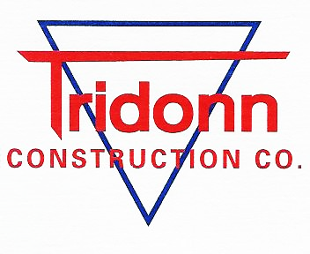
1461 Evanston Avenue, Muskegon, MI 49442
231-777-2681 ● Fax 231-777-2506

Weekly Work Update

Project: 129 W. Ludington Ave

Week Ending: 3-1-2024

- CMU Block Walls
- Working on West Stairwell

Work Planned for Week Ending 3-8-2024

- Continue to work on CMU walls
- Finish West Stairwell
- Full Closure of Rath Ave 3-4-2024 (Min 7 wks)
- Start to mobilize steel erectors

